|  |  |
| --- | --- |
|  | **FPT ACADEMY INTERNATIONAL**  **FPT - APTECH COMPUTER EDUCATION** |

**Centre Name: ACE-HCMC-2-FPT.**

**Address: 590 Cach Mang Thang 8, District 3, Ho Chi Minh City, Viet Nam.**

GREEN GROVES

|  |  |  |
| --- | --- | --- |
| **Supervisor** | : Ms. Le Mong Thuy | |
| **Semester** | : 1 | |
| **Batch No** | : T1.2406.E1 | |
| **Group No** | : 4 | |
| **Member** | | |
| **Order** | **Name** | **Student ID** |
| **1** | Pham Nguyen Hung | Student1576000 |
| **2** | Duong Quang Khang | Student1580659 |
| **3** | Pham Huy Thien | Student1575529 |

Date: Sep, 2024

|  |  |  |  |
| --- | --- | --- | --- |
|  | **This is to certify that** | |  |
| Mr. Pham Nguyen Hung | |
| Mr. Duong Quang Khang | |
| Mr. Pham Huy Thien | |
| **Have successfully designed & developed:** | |
| eProject: Green Groves | |
| **Submitted by:** | |
| Ms. Le Mong Thuy | |
| **Date of start:** | 26 - Sep - 2024 |
| **Authorized Signature:** | |
|  | |
|  | |

Table of Contents

ACKNOWLEGMENT 5

SYNOPSIS 5

ANALYSIS 5

**1.** **Purpose of Green Groves** 5

**2.** **Design and Interface.** 6

**3.** **Technical Requirements** 6

CUSTOMER'S REQUIREMENTS SPECIFICATIONS 6

**1.** **Business/Project Objective.** 6

*1.1.* *Home Page* 6

*1.2.* *Gardening Techniques and Tips* 6

*1.3.* *Gardening Tools* 6

*1.4.* *Gardening Essentials* 7

*1.5.* *Pots and Containers* 7

*1.6.* *Gardening Accessories* 7

*1.7.* *Product Suggestions* 7

*1.8.* *Educational Videos* 7

*1.9.* *Related Books* 7

*1.10.* *About Us & Contact Us* 7

*1.11.* *Design and Usability* 7

**2.** **Hardware/ Software Requirements.** 8

*2.1.* *Hardware Requirements* 8

*2.2.* *Software Requirements.* 8

SCOPE OF THE WORK (IN BRIEF) 9

**1.** **Home:** 9

**2.** **Gardening Info:** 9

**3.** **Essentials:** 9

**4.** **Pots & Accessories:** 9

**5.** **Resources:** 9

**6.** **About & Contact:** 9

ARCHITECTURE AND DESIGN OF THE SYSTEM 10

DIAGRAM OF THE WEBSITE 11

WEBSITE DESCRIPTION 12

**1.** **Header:** 12

1.1. Description: 12

1.2. Sceenshot: 12

**2.** **Home:** 12

2.1. Description: 12

2.2. Screenshot: 12

**3.** **Gardening info:** 14

3.1. Articles and Guides: 14

3.2. Improvement Tips 15

3.3. Tool List 16

Picture3.3. Tool List 16

**4.** **Essentials:** 17

4.1. Soil and Fertilizers 17

Picture4.1 .Soil and Fertilizers 17

4.2. Pesticides 17

Picture4.4.. Pesticides 18

4.3. Seeds 18

**5.** **Pots & Accessories.** 19

**6.1.** **Recomment Product.** 20

**6.2.** **Educational Videos** 20

**6.3.** **Related Books** 21

**7.** **About & Contact.** 21

**8.** **Site map** 22

Table of Pictures and Diagrams

Picture 1. Architecture and design 10

Picture 2. Diagram. 11

# **ACKNOWLEGMENT**

First of all, I would like to say hello to the teachers and classmates who have successfully completed this eProject report. The teacher has also been a great help to us since we started studying at FPT Aptech. With this eProject, she has guided us very meticulously, enthusiastically, and seriously. With her guidance, we were able to successfully complete this Green Groves project. I would also like to thank all the members of the group, each of whom has worked hard and diligently to complete the eProject seriously over the month we worked together. Our group would like to thank our classmates for creating the best environment for us to focus on the project and for providing opportunities for our group to learn and gain more knowledge.

# **SYNOPSIS**

Green Groves is a comprehensive website dedicated to providing essential information and resources for gardening enthusiasts, particularly those interested in small-scale gardening, such as balcony, terrace, and home gardens. Understanding the challenges faced by urban gardeners and those with limited space, the website offers a wealth of resources, including step-by-step guides, practical tips, and in-depth articles on various gardening techniques. By addressing the common lack of knowledge and precise information about gardening, Green Groves empowers users to engage in gardening activities with confidence and ease. Whether you are a novice looking to start your first garden or an experienced gardener seeking new ideas, Green Groves serves as a valuable companion on your gardening journey, fostering a deeper connection to nature and promoting sustainable practices.

# **ANALYSIS**

1. **Purpose of Green Groves**

The purpose of Green Groves is to serve as a dedicated resource for gardening enthusiasts, particularly those interested in small-scale gardening, including balcony, terrace, and home gardens. The website seeks to address the common gaps in knowledge and access to accurate information about gardening practices. By providing a variety of essential resources, such as detailed guides, practical tips, and expert advice, Green Groves empowers users to cultivate their green spaces with confidence and ease. Ultimately, the website aims to inspire a love for gardening and promote sustainable practices, making it easier for individuals to connect with nature and enjoy the many benefits of gardening, regardless of their experience level.

1. **Design and Interface.**

* The website features a user-friendly environment and navigation. Key menus  
  are positioned at the top for easy access to information.
* The interface and color scheme are harmoniously combined to create a visually  
  appealing and engaging experience for users.

1. **Technical Requirements**

* The portal will be designed as a Single-Page Application (SPA)
* It will be a responsive website.
* The website will include a set of pages and menus representing a choice of activities.
* Pages, menus, and visual elements must be designed to be visually appealing.
* Attractive fonts, colors, and animations will be used.
* All elements should be laid out in a responsive manner.

# **CUSTOMER'S REQUIREMENTS SPECIFICATIONS**

**Client: Green Groves.**

1. **Business/Project Objective.**

The portal will be designed as a Single-Page Application (SPA) and a responsive website, featuring a set of pages and menus that represent a variety of activities to be performed. The pages, menus, and other visual elements must be crafted in a visually appealing manner, incorporating attractive fonts, colors, and animations.

All of these should also be laid out in a responsive manner.

The Web site is to be created based on the following requirements:

* 1. *Home Page*
* A visually appealing logo representing Green Groves, accompanied by banners highlighting key gardening concepts and visuals.
* A user-friendly navigation menu with submenus linking to different sections of the website.
  1. *Gardening Techniques and Tips*
* Detailed articles and guides on various gardening techniques.
* Tips for better gardening practices tailored for small-scale gardens.
  1. *Gardening Tools*
* A comprehensive list of gardening tools with descriptions and usage instructions.
* Short, informative videos demonstrating the use of various gardening tools.
  1. *Gardening Essentials*
* Information on different types of soil and fertilizers suitable for small gardens.
* Guidelines on using pesticides safely and effectively.
* Information about various seeds, their planting seasons, and care instructions.
  1. *Pots and Containers*
* Tips on choosing proper pots, pot plates, wall-mounted brackets, pot hangers, and railing brackets for different types of plants.
  1. *Gardening Accessories*
* Suggestions for adding decorative elements to gardens, such as miniature garden toys.
* A list of useful accessories to enhance gardening activities.
* Ideas for using decorative pebbles to beautify small gardens.
  1. *Product Suggestions*
* A curated section providing recommendations for buying various gardening-related products, including tools, accessories, and books.
  1. *Educational Videos*
* A collection of informative and illustrative videos on gardening topics, optimized for quick loading and viewing.
  1. *Related Books*
* A section where users can explore and check for books related to gardening, with options to purchase or borrow.
  1. *About Us & Contact Us*
* Information about the team behind Green Groves and the mission of the website.
* Display contact details and location using GeoLocation API (e.g., Google Maps).
  1. *Design and Usability*
* A well-designed menu with necessary sub-menu options.
* A uniform color combination throughout the website.
* Smooth navigation across all pages.

Over and above this, the portal should implement the following functionalities:

* Display a continuous scrolling ticker at the bottom of the page with current date, time, and location (hint: Use geolocation features of HTML5).
* Display a visitor count at the top right corner of the page beside a logo image.
* The menu options should change color on hover and after clicking.
* Fade in and fade out options can be used for the menus.

1. **Hardware/ Software Requirements.**
   1. *Hardware Requirements*
   * Intel Core i3/i5 Processor or higher
   * 8 GB RAM or above
   * Color SVGA
   * 500 GB Hard Disk space
   * Mouse
   * Keyboard
   1. *Software Requirements.*

Technologies to be used:

* Frontend: HTML5, CSS, Bootstrap, JavaScript, jQuery, React/AngularJS, Figma, XML
* Data Store: JSON files or TXT files

Other Requirements:

* Operating Portal: Windows
* Browsers: Edge, Chrome, Mozilla Firefox, Safari

# **SCOPE OF THE WORK (IN BRIEF)**

1. **Home:**

Logo representing Green Groves, highlighting key gardening concepts and visuals.

1. **Gardening Info:**

***Articles & Guides:*** Detailed articles and tutorials on various gardening techniques.

***Improvement Tips:*** Tips for improving gardening practices, especially for smaller gardens.

***Tool List:*** Complete list of garden tools with descriptions and instructions.

1. **Essentials:**

***Soil & Fertilizers:*** Information on soil types and fertilizers suitable for small gardens.

***Pesticides:*** Guidelines for the safe and effective use of pesticides.

Seeds: Information on seed types, planting seasons and care instructions.

1. **Pots & Accessories:**

***Pots & Containers:*** Tips for choosing pots, pot saucers, wall mounts, pot holders and orchid stands that can be suitable for each type of plant.

***Accessories:***

* Suggestions for adding decorative elements to your garden.
* List of useful accessories to enhance your gardening activities.

***Decorative Rocks:*** Ideas for using decorative pebbles to beautify small gardens.

1. **Resources:**

***Product Suggestions:*** A curated section providing recommendations for buying various gardening-related products, including tools, accessories, and books.

***Educational Videos:*** A collection of informative and illustrative videos on gardening topics, optimized for quick loading and viewing.

***Related Books:*** A section where users can explore and check for books related to gardening, with options to purchase or borrow.

1. **About & Contact:**

* Information about the team behind Green Groves and the mission of the website.
* Display contact details and location using GeoLocation API (e.g., Google Maps or any other).

# **ARCHITECTURE AND DESIGN OF THE SYSTEM**

|  |
| --- |
|  |

Picture 1. Architecture and design

**DIAGRAM OF THE WEBSITE**

|  |
| --- |
|  |
| Picture 2. Diagram. |

**WEBSITE DESCRIPTION**

1. **Header:**
   1. Description:

* Top Header: Includes visitor count, phone number, email, login, register. When logged in, the avatar will be displayed, and when logged out, Login and Register will be displayed.
* Body Header: Includes logo, name, main menu, and submenus.
  1. Sceenshot:

|  |
| --- |
|  |
|  |
| Picture1. Header and responsive |

1. **Home:**
   1. Description:

* There is a banner and a blog. Each blog, when clicking on 'View Details,' will lead to that blog's page.
  1. Screenshot:

|  |
| --- |
|  |
|  |
| Picture2. Home page |

1. **Gardening info:**
   1. Articles and Guides:
2. Description:

* There are article titles and guides. If you click on them, you'll be able to read the specific article or guide.

1. Screenshot:

|  |
| --- |
|  |
|  |
| Picture3.1. Articles and Guides |

* 1. Improvement Tips
  2. Tool List
     1. Description:
* There are useful gardening tools, a filter set, and instructions for using each item.
  + 1. Screenshot:

|  |
| --- |
|  |
|  |
| Picture3.3. Tool List |

1. **Essentials:**
   1. Soil and Fertilizers
      1. Description:

* There is a variety of soil and fertilizers, each with detailed descriptions of their types and uses. There are also separate filtering options for soil and fertilizers.
  + 1. Screenshot:

|  |
| --- |
|  |
|  |
| Picture4.1 .Soil and Fertilizers |

* 1. Pesticides
     1. Description:
* Classifying each type of pesticide and providing detailed instructions for each type.
  + 1. Screenshot:

|  |
| --- |
|  |
|  |
| Picture4.4.. Pesticides |

* 1. Seeds

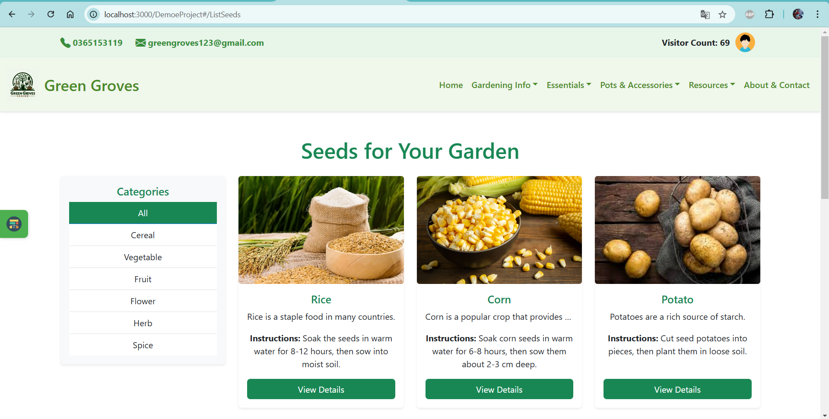

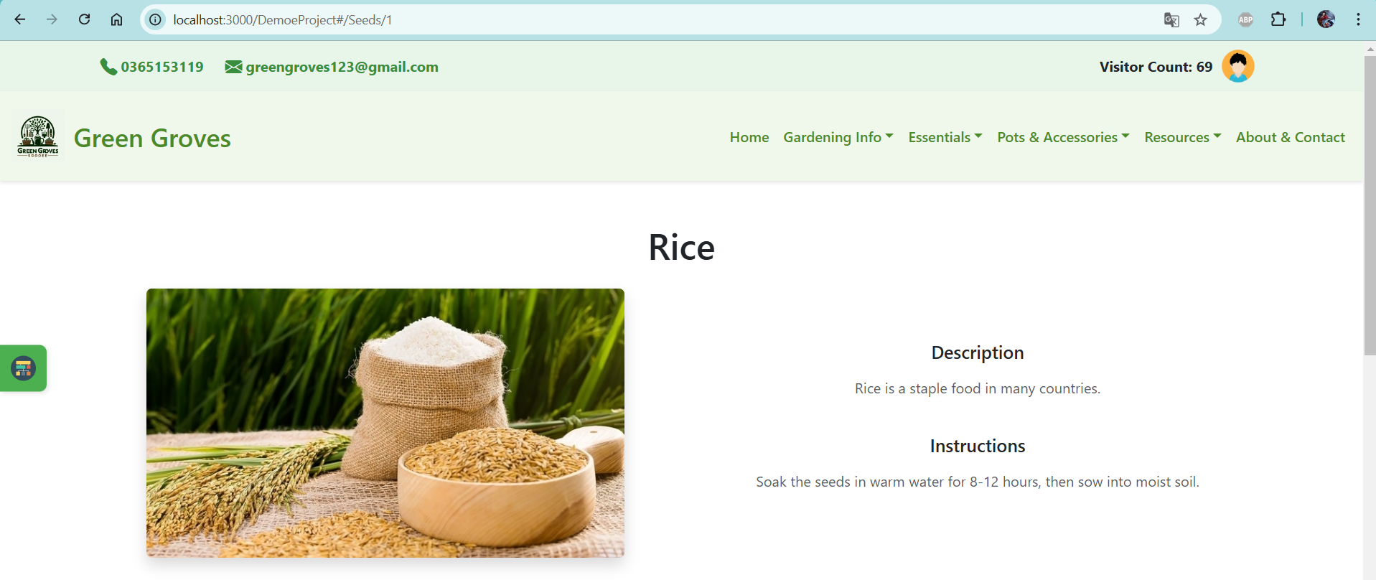

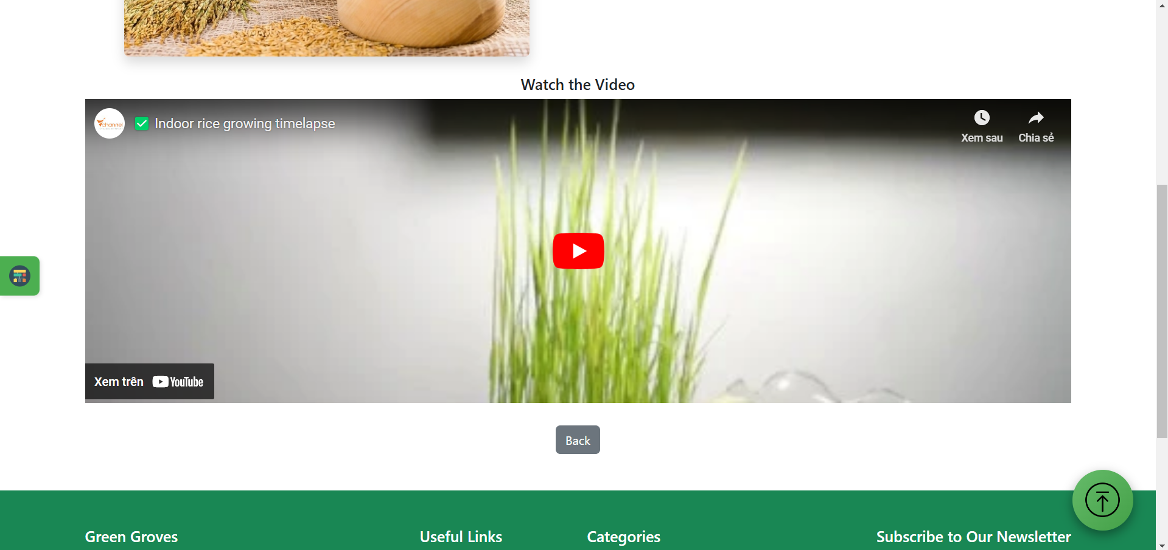

1. **Pots & Accessories.**

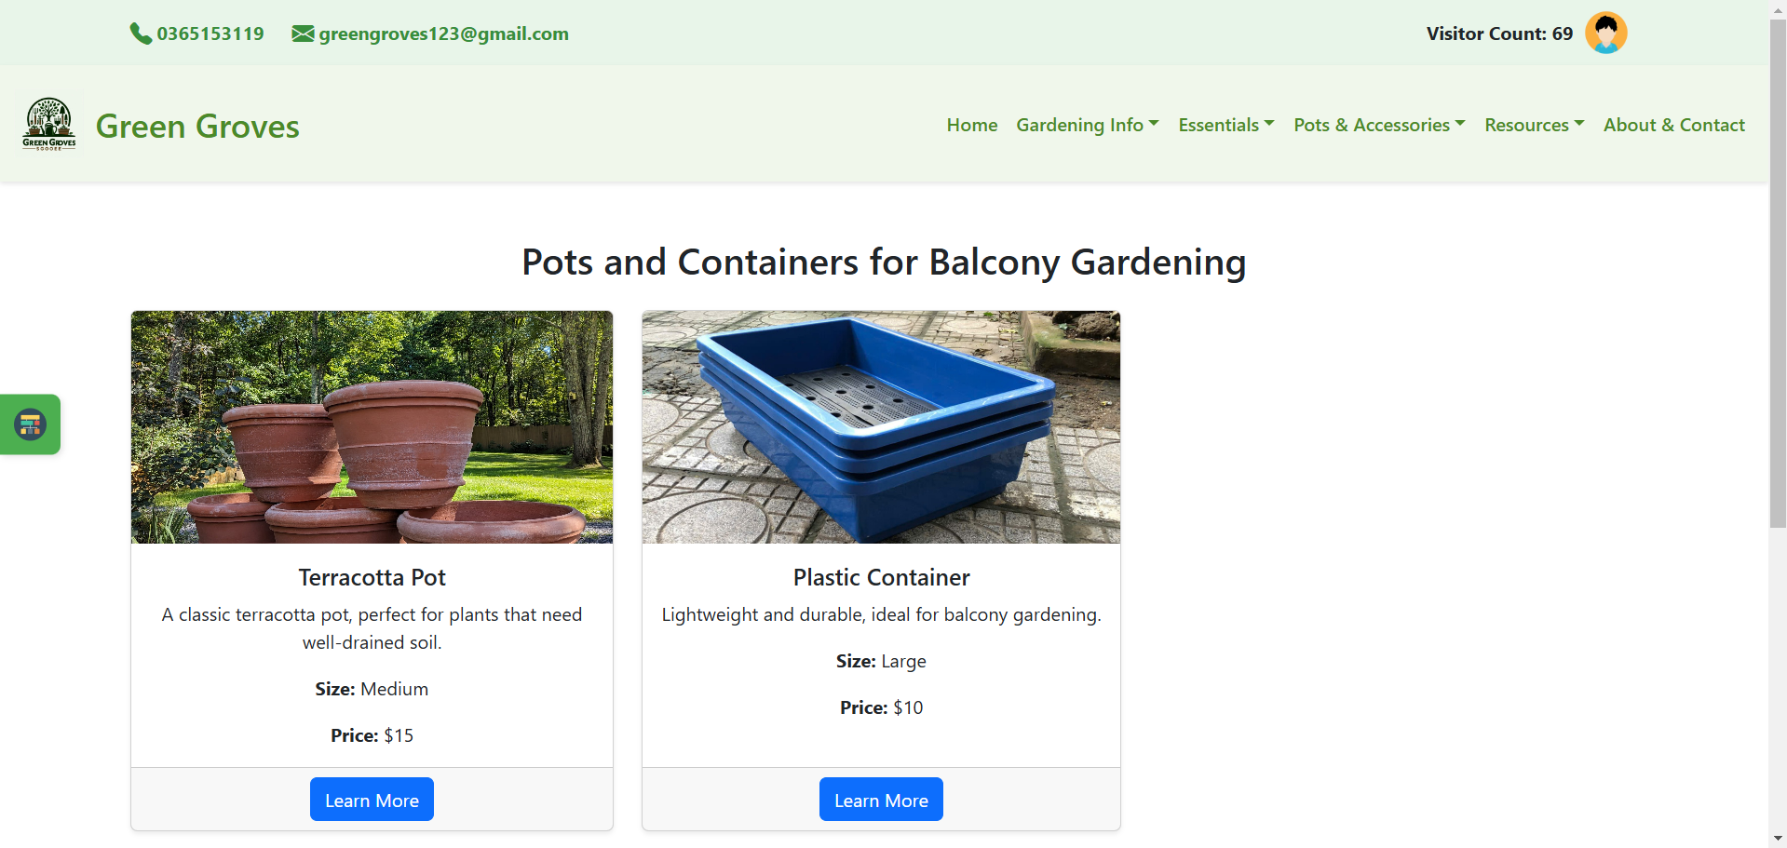

* 1. **Recomment Product.**

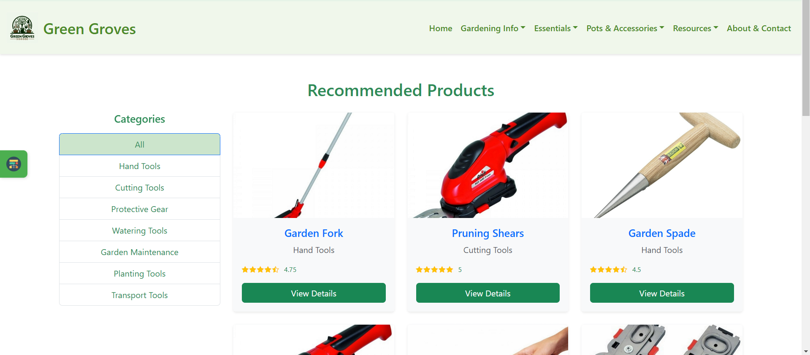

* 1. **Educational Videos**

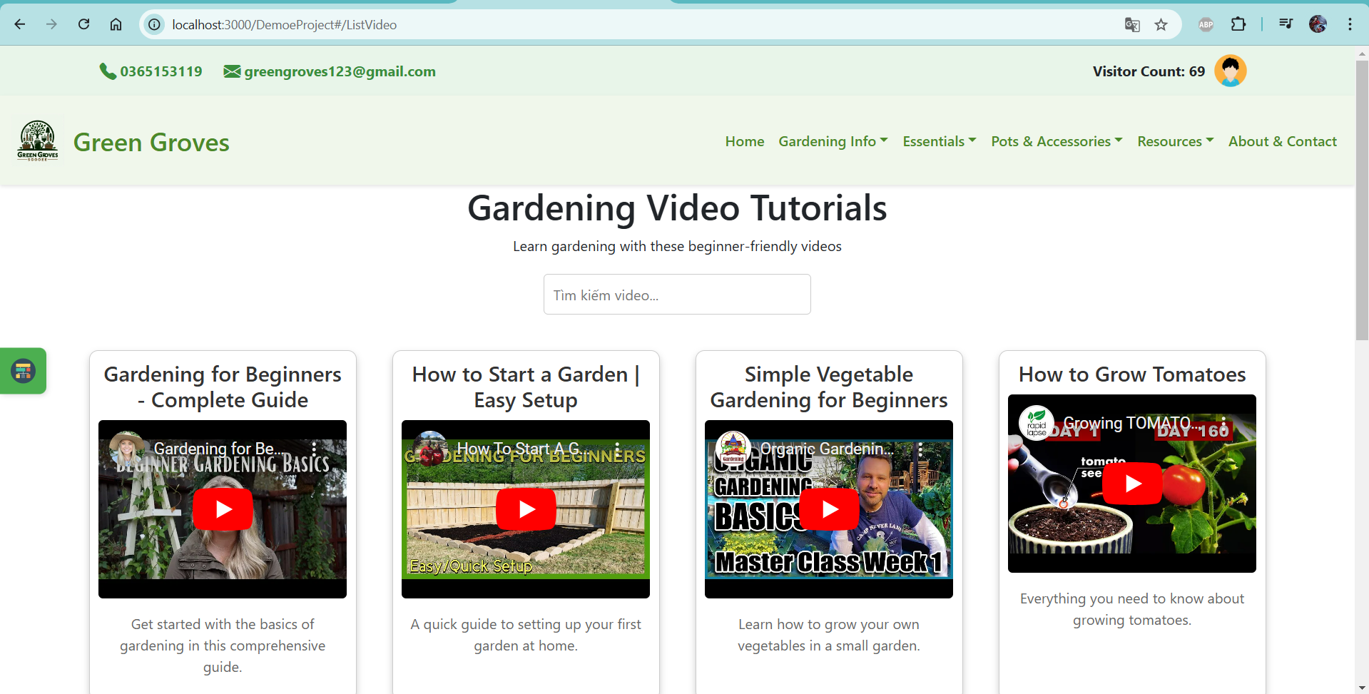

* 1. **Related Books**

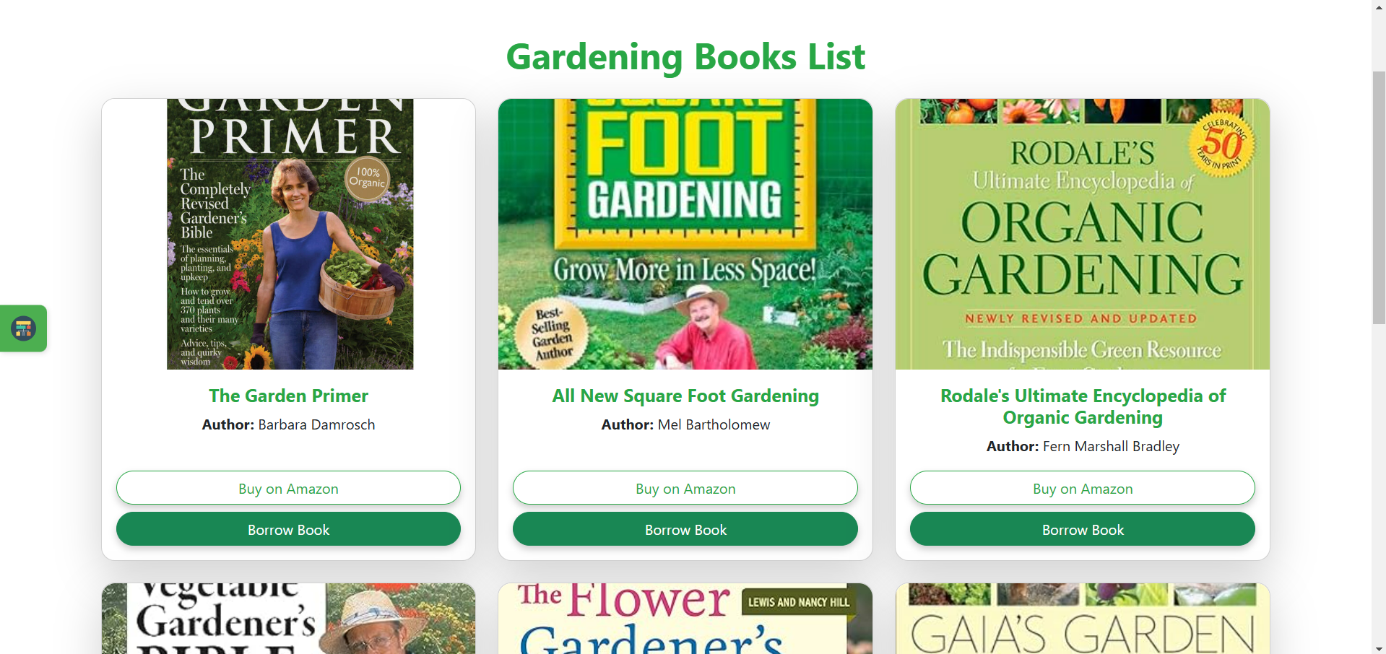

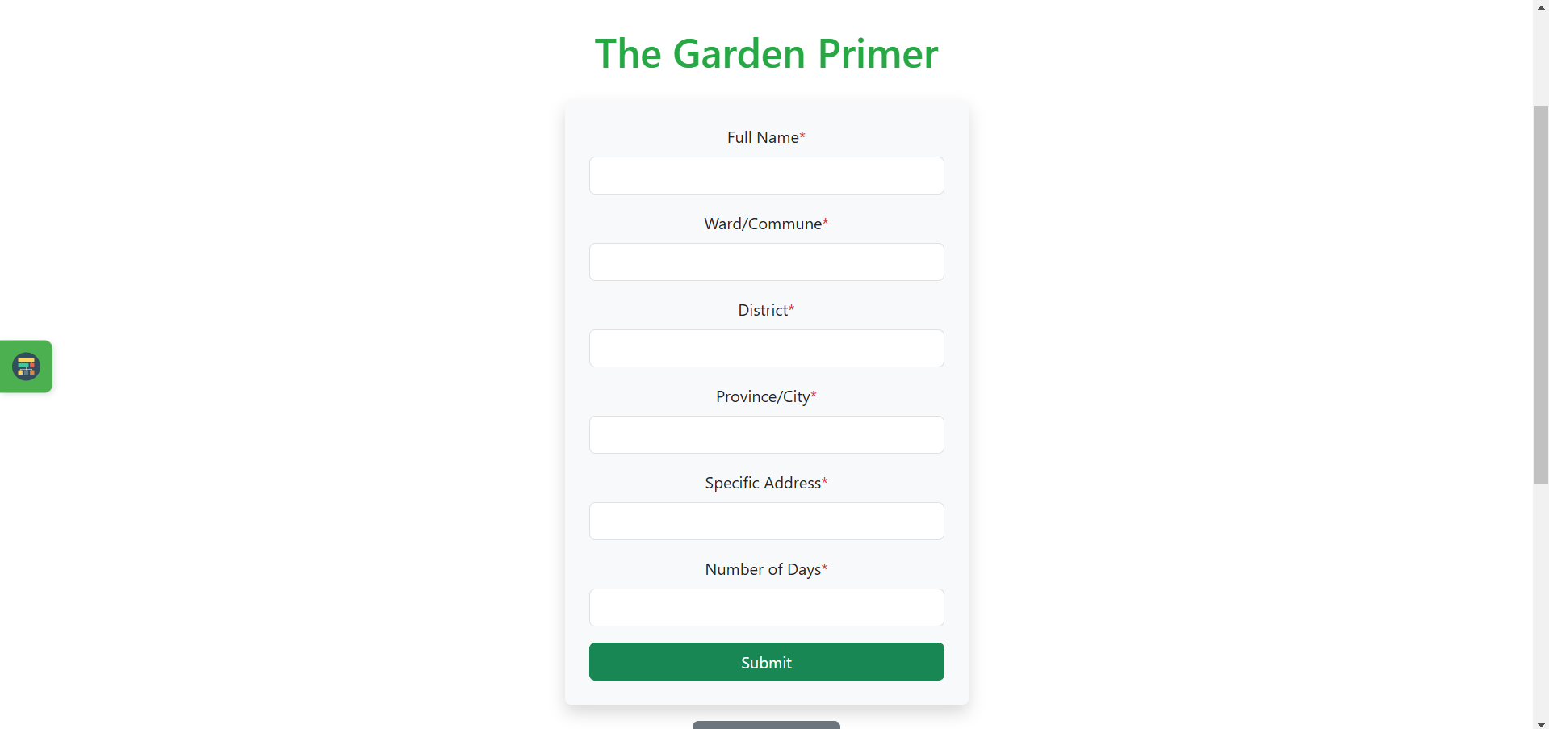

1. **About & Contact.**

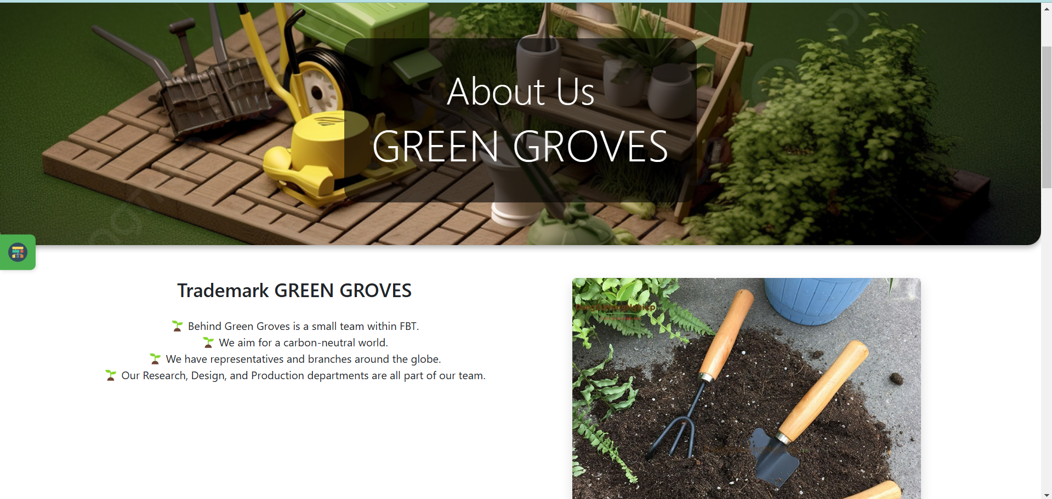



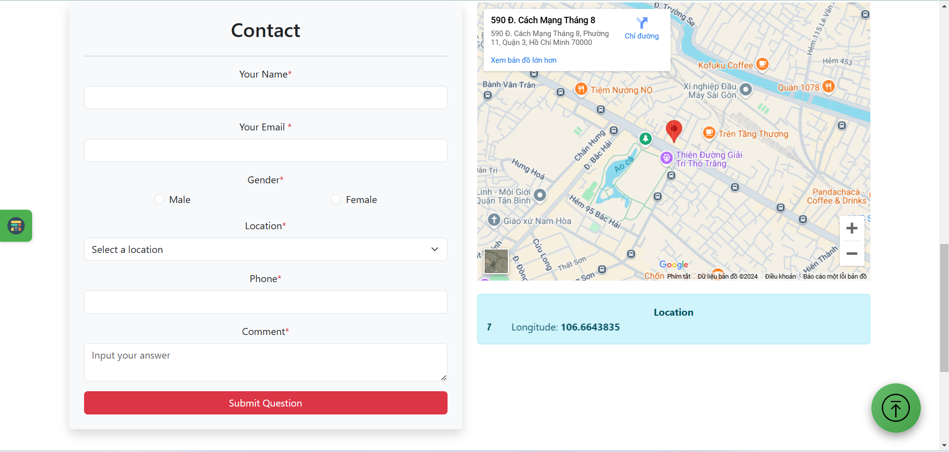

1. **Site map**

